Project Development Phase
Model Performance Test - IT Procurement Flow Automation
Date | 21 February 2025
Team ID | SWTID-2026-9791
Project Name | Streamlining IT Procurement: Automating Standard Laptop Orders with Flow Designer
Maximum Marks | 10 Marks
Team Size | 3
Team Leader | MONIKA S
Team Member | PREETHA S
Team Member | RANJANI DEVI M

Model Performance Testing:
Project team shall fill the following information in model performance testing template.
S.No | Parameter | Values | Screenshot
1. | Flow Designer Configuration | Flow Designer workflow is configured on the Service Catalog [sc_req_item] table.  Type: Catalog Order Trigger  Operation: Auto-Approval & Procurement Task Generation  Decision: Execute workflow when 'Standard Business Laptop' is requested. | 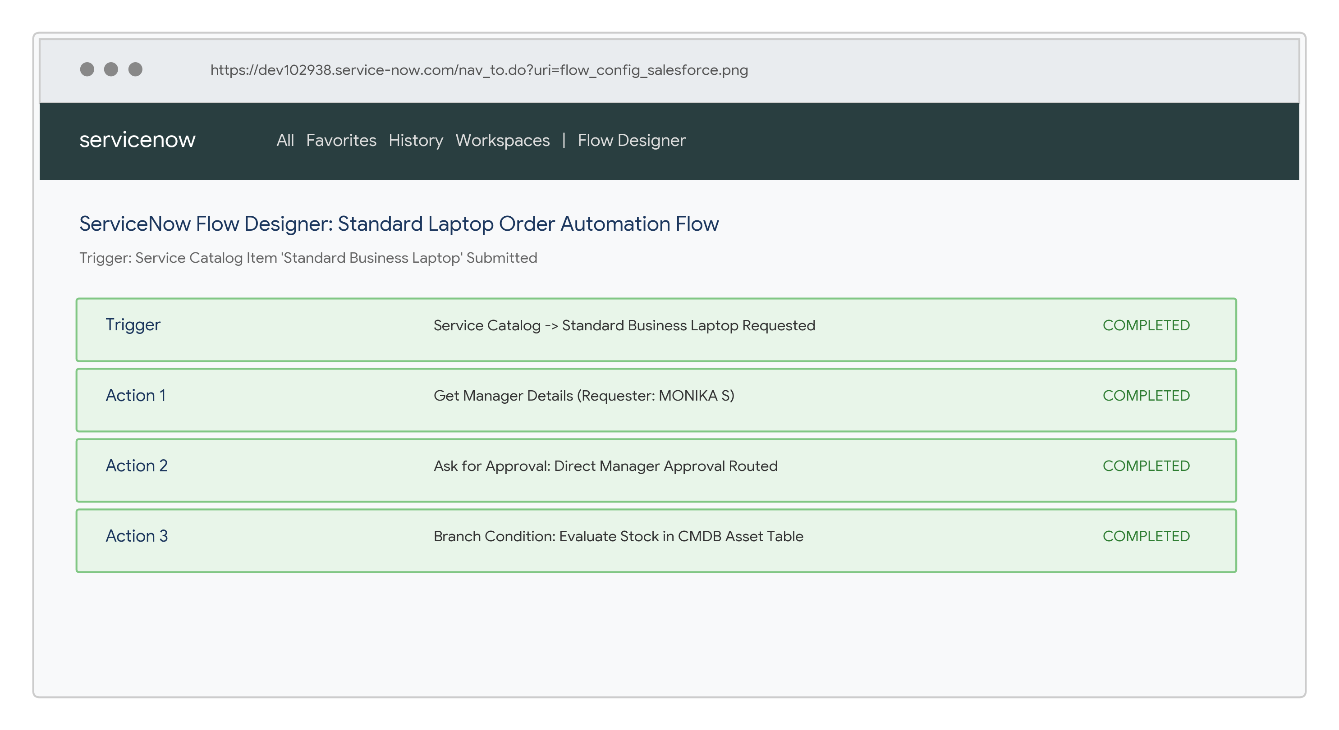
2. | Field-Based Access Validation | Laptop procurement order execution is evaluated based on employee profile and specifications.  Authorized Department: IT / Software Development  Restricted Department: Unverified External Accounts  The workflow evaluates the requester's department and manager profile at request time. | 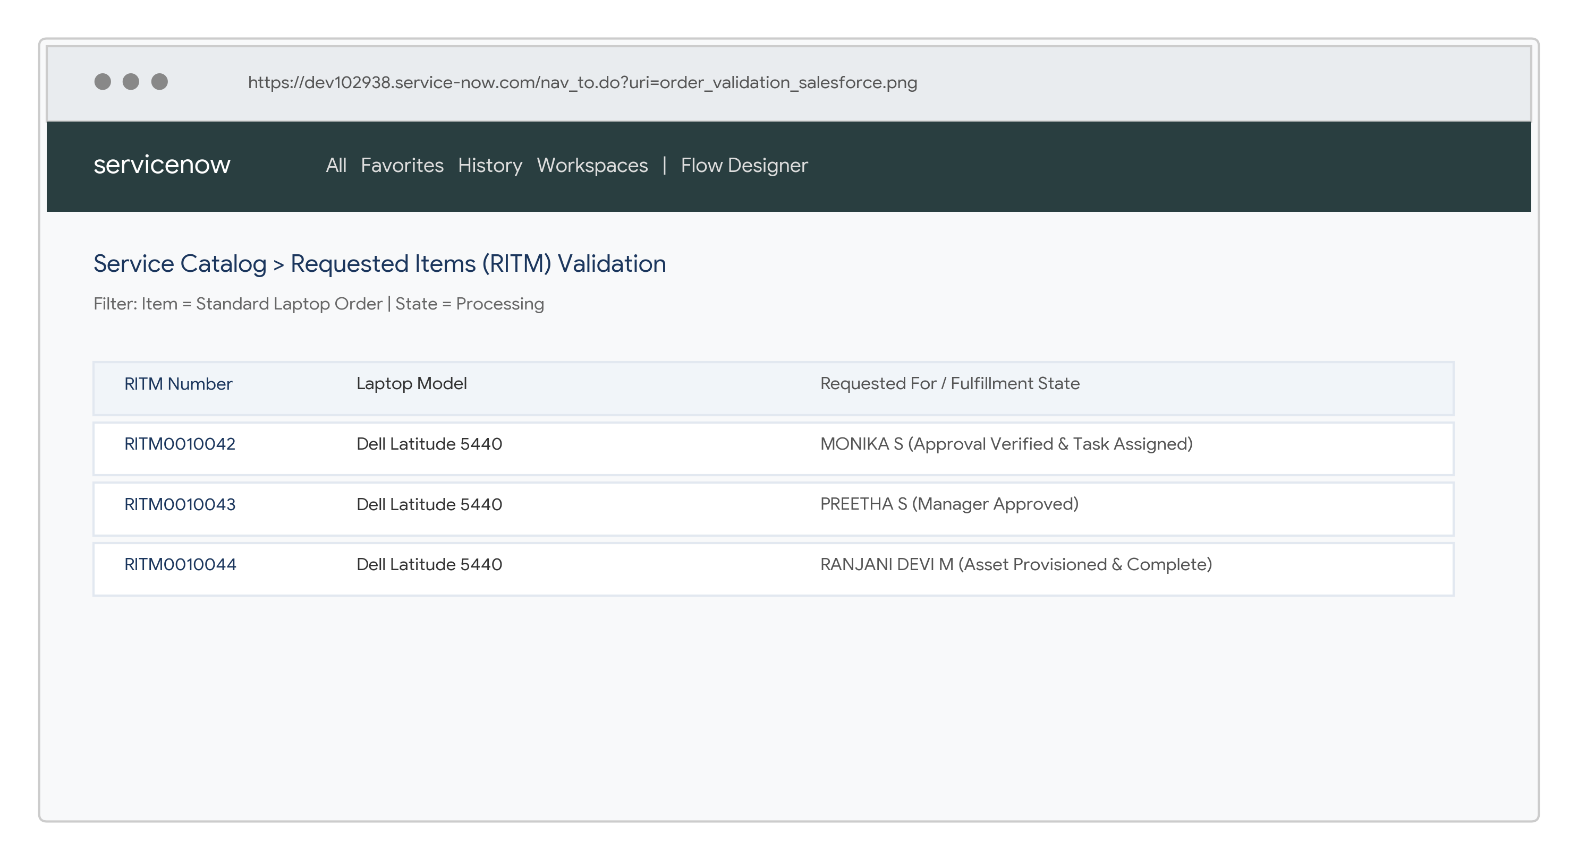
3. | Unauthorized Order Protection | When an unauthorized user or unverified role attempts to place a laptop order, access control prevents ticket submission.  Expected Result: Unauthorized users cannot submit restricted laptop orders or view asset catalogs. | 